SUPPLEMENTARY TABLE 11, FIGURES 1-8

Trawl and eDNA Assessment of Marine Fish Diversity, Seasonality, and Relative Abundance in Coastal New Jersey, U.S.A

Authors: Mark Y. Stoeckle

Jason Adolf

Zachary Charlop-Powers

Keith J. Dunton

Greg Hinks

Stacy M. VanMorter

Table 11. Water quality conditions by month and depth

Fig. 1. Shannon-Wiener diversity indices

Fig. 2. Reads vs. biomass by month, plotted with absolute values (i.e., not percents)

Fig. 3. Combined monthly plots with absolute values

Fig. 4. Reads vs. biomass plots for eDNA sites only, analyzed by month and by tow, absolute values

Fig. 5. Geographic localization of Atlantic angel shark by trawl, eDNA

Fig. 6. Reads vs. biomass plots for selected taxonomic groupings

Fig. 7. Repeat amplification and sequencing

Fig. 8. PhiX comparison

**Supplementary Table 11.** Water quality conditions by month and depth. Average values ± coefficient of variation shown (S= surface, 0 m—2 m; B = bottom, Zmax – Zmax-2m). Values are averages for all tows, regardless of whether water was collected for eDNA.

|  |  |  |  |  |  |  |
| --- | --- | --- | --- | --- | --- | --- |
| **Mon.** | **Depth** | **Temp. (°C)** | **DO (% sat.)** | **DO (mg L-1)** | **Salinity** | **pH** |
| **JAN** | **S** | 5.9 ± 14.2% | 102 ± 3.0% | 10.4 ± 4.5% | 31.0 ± 4.1% | 8.0 ± 0.6% |
|  | **B** | 6.1 ± 16.5% | 99.8 ± 2.9% | 10.1 ± 5.1% | 31.4 ± 3.2% | 8.0 ± 0.6% |
| **JUN** | **S** | 21.9 ± 7.03% | 112.3 ± 6.6% | 8.3 ± 6.9% | 29.1 ± 6.8% | 8.1 ± 1.4% |
|  | **B** | 13.1 ± 22.9% | 79.1 ± 15.7% | 6.8 ± 13.1% | 31.7 ± 3.9% | 7.8 ± 1.4% |
| **AUG** | **S** | 23.1 ± 10.6% | 103.3 ± 17.4% | 7.4 ± 15.5% | 30.8 ± 2.0% | 7.9 ± 2.0% |
|  | **B** | 16.2 ± 23.6% | 67.8 ± 31.6% | 5.5 ± 28.7% | 31.8 ± 1.9% | 7.8 ± 2.1% |
| **NOV** | **S** | 15.1 ± 4.7% | 98.3 ± 2.8% | 8.2 ± 2.9% | 30.9 ± 5.8% | 7.8 ± 0.7% |
|  | **B** | 15.5 ± 5.7% | 94.8 ± 5.2% | 7.8 ± 6.1% | 31.8 ± 2.3% | 7.8 ± 0.8% |

**Supplementary Fig. 1.**  Comparisons of Shannon-Weiner diversity by trawl (average per tow) and by eDNA (average per sample). All tows were included whether or not there was a matched eDNA sample. Statistical analysis at bottom.

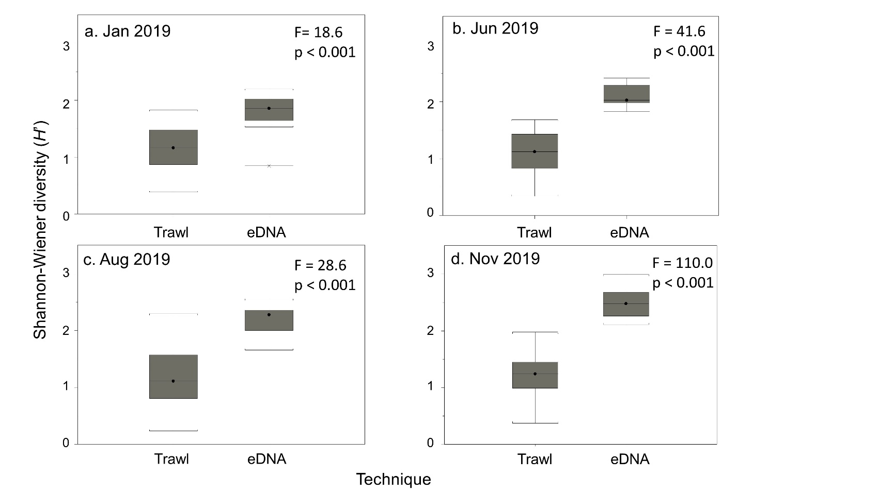

ANOVA with H’ as response and ‘Technique’ (eDNA or Trawl) and ‘Trip’ (Jan, Jun, Aug, Nov) as factors. Df= degrees of freedom; SS= sum of squares; MS = mean square; F = ANOVA test statistic; P = p-value. All trawl samples were used.

**Term Df SS MS F P**

Technique 1 26.8 26.8 161.3 <0.001

Trip 3 1.5 0.5 3.1 0.03

Technique x Trip 3 1.7 0.6 3.4 0.02

Residuals 175 29.1 0.2

**Supplementary Fig. 2.** Reads vs. biomass by month, plotted with absolute values (i.e., not percents; compare to text Fig. 6). Each point represents a species detected by trawl and eDNA in that month. Trend line and values show linear regression.

**Supplementary Fig. 3.** Combined monthly reads vs. biomass and vs. surface area index, plotted with absolute values. Compare to text Fig. 7, which compiles data analyzed as monthly percent. Trend line and values show linear regression.

**Supplementary Fig. 4.** Reads vs. biomass at eDNA sites, analyzed by month and by tow, plotted with absolute values. For the latter, species eDNA reads from water samples at a given site were compared to trawl biomass at that site. Trend line and values show linear regression. Compare to text Fig. 7, Supplementary Fig. 3.

**Supplementary Fig. 5.** Geographic localization of Atlantic angel shark by trawl, eDNA. June and August tows and samples are shown; Atlantic angel shark was not caught or detected in January or November.

**Supplementary Fig. 6.** Reads vs. biomass for selected taxonomic groups.Log-log plots cover survey year; each point represents a single species during a single month. (A) Pleuronectiformes (B) Gadiformes and Labriformes combined, C) Selachii (Carcharhiniformes, Squaliformes, Lamniformes).

**Supplementary Fig. 7.** Reproducibility of eDNA processing. Repeat amplification, indexing, and sequencing were performed on 10 eDNA samples collected in August 2019. Each point corresponds to pooled reads from a single species. Original data in Supplementary Table 9.

**Supplementary Fig. 8.** PhiX effect. A set of 20 eDNA libraries from November 2019 were sequenced without and with 20% PhiX spike-in. Each point corresponds pooled reads from a single species. Original data in Supplementary Table 10.

